**Lancaster COVID-19 transmission model**

* Deterministic SEIR metapopulation model, with stoachstic transmission effect captured by negative binomial noise added to number of new infections.
* England only; at local authority district (LAD) resolution
* Population stratified by LAD and 5yr age groups; 2011 census used to estimate number in each location/age combination
* Thus, we are modelling infection within and between 17 * 152 ‘subpopulations’ (age and LAD combinations).
* Assumed latent period of 4 days (similar to SARS); note this is not the same as incubation period, but the period from infection to being infectious, symptoms may develop later
* Fitted to nationally aggregated daily number of reported cases, up to 2020-03-29; FUTURE this will change to spatial counts when data is available from PHE
* Inferring
  + transmission rate (beta),
  + infectious period (1/gamma),
  + number initially infected in Greater London, West Midlands and greater Manchester (distributed on ratio 3.7:1:1) on 2020-02-19
  + overdispersion parameter for negative binomial noise (r)
  + FUTURE: new transmission rate for post-lockdown period
* Contact structure:
  + within LAD, age-based mixing based on POLYMOD data: full POLYMOD up to 2020-03-23, after which modified POLYMOD ‘no-school’ age-mixing used, to represent lock-down effect and school closure.
  + between LADs, spatial transmission coupling based on 2011 census commuting data, which scales down by day during the epidemic period, using department of transport rail ticket sales data (figure 1).

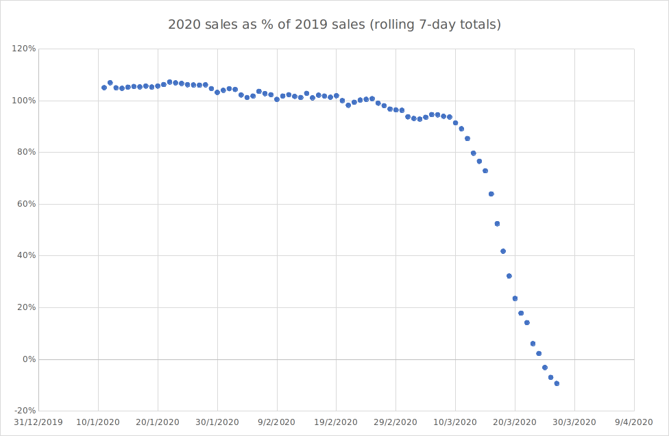

Figure 1. Reduction in travel ticket sales, y-axis deliberately cropped as sensitive information.

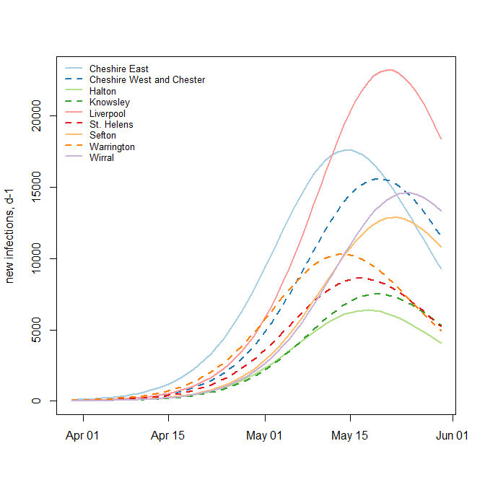

Figure 2. Mean epidemic trajectories for 9 LADs in North West. These are the number of ‘true’ daily new infections in the community, not what would present at hospital or interact with healthcare. Note, there is uncertainty around these estimates, not shown on this plot.

**Hospital demand model**

Using output from the transmission model (number of new symptomatic infections per day, by age group and location), we calculate the following:

1. number in each age-LAD that will seek care
2. number in each age-LAD that will seek care and be admitted
3. number admitted in each age-LAD that require ICU
4. number of admitted non_ICU discharged per day
5. number of admitted ICU discharged per day
6. number of admitted non_ICU that die per day
7. number of admitted ICU that die per day

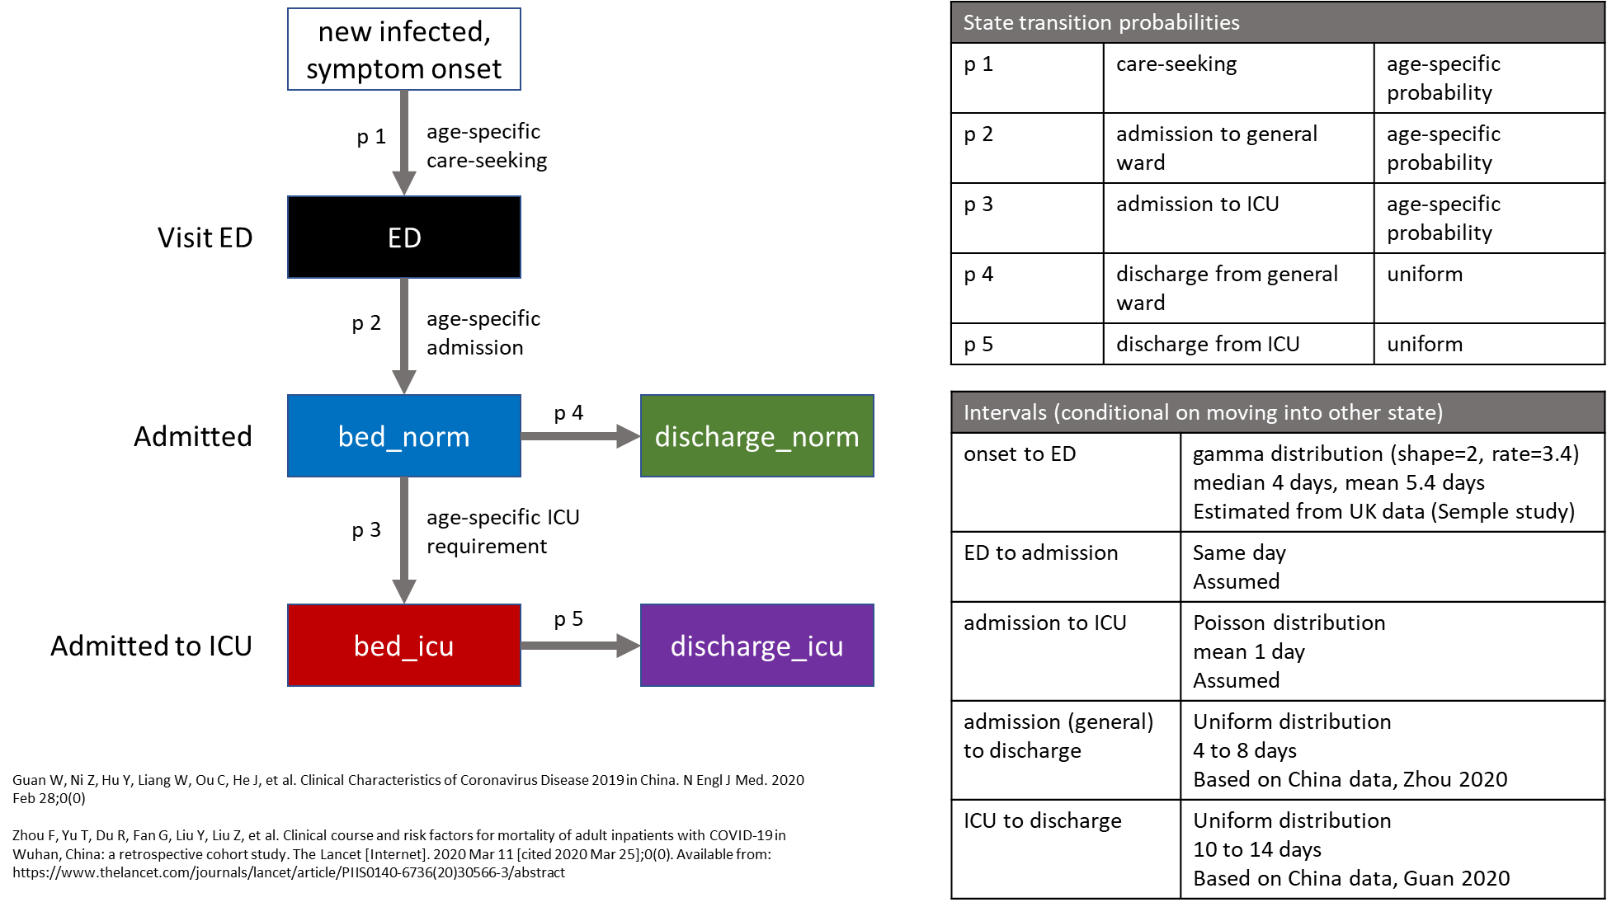

Figure 3. Schematic of demand model

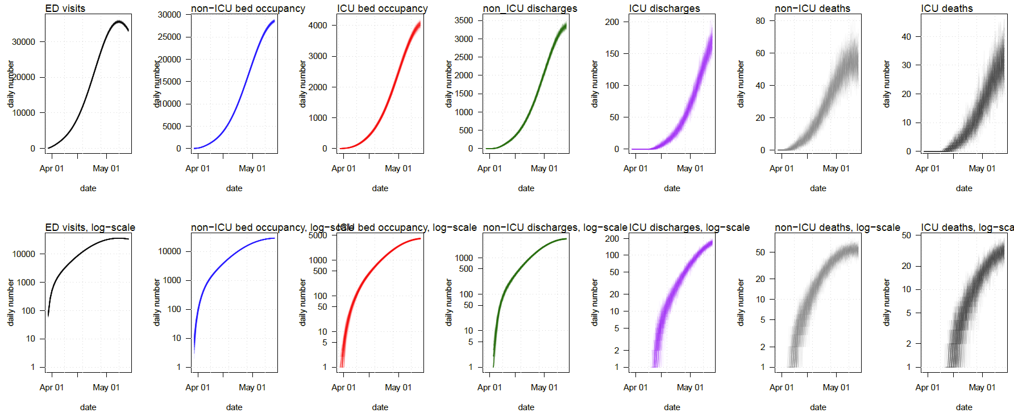

Figure 4. Demand for entire region (9 LADs). Note, occupancy is the number of beds occupied each day, while ED visits, discharges and deaths are the daily number. Also note that length of stay is assumed to be the same for both alive and dead outcomes, and lag considerably behind the epidemic in the community and admittance.

Table 1. Assumed/estimated probabilities.

|  |  |  |  |  |  |  |  |  |  |  |  |  |  |  |  |  |  |
| --- | --- | --- | --- | --- | --- | --- | --- | --- | --- | --- | --- | --- | --- | --- | --- | --- | --- |
| Type | 0-4 | 5-9 | 10-14 | 15-19 | 20-24 | 25-29 | 30-34 | 35-39 | 40-44 | 45-49 | 50-54 | 55-59 | 60-64 | 65-69 | 70-74 | 75-79 | 80+ |
| Proportion with any symptoms | 0.66 | 0.66 | 0.66 | 0.66 | 0.66 | 0.66 | 0.66 | 0.66 | 0.66 | 0.66 | 0.66 | 0.66 | 0.66 | 0.66 | 0.66 | 0.66 | 0.66 |
| IFR | 0.0001 | 0.0001 | 0.0001 | 0.0001 | 0.0004 | 0.0004 | 0.0009 | 0.0009 | 0.0015 | 0.0015 | 0.0069 | 0.0069 | 0.0221 | 0.0221 | 0.0592 | 0.0592 | 0.0876 |
| Age specific scaling of ifr to give hospitalisation | 0.055 | 0.055 | 0.055 | 0.055 | 0.055 | 0.055 | 0.055 | 0.055 | 0.053 | 0.053 | 0.0283 | 0.0283 | 0.0203 | 0.0203 | 0.0122 | 0.0122 | 0.01 |
| Proportion of infections hospitalised | 0.0024 | 0.0024 | 0.0034 | 0.0034 | 0.0105 | 0.0105 | 0.0234 | 0.0234 | 0.0395 | 0.0395 | 0.0981 | 0.0981 | 0.225 | 0.225 | 0.362 | 0.362 | 0.4379 |
| Proportion of infections needing critical care | 0.0001 | 0.0001 | 0.0001 | 0.0001 | 0.0003 | 0.0003 | 0.0006 | 0.0006 | 0.0011 | 0.0011 | 0.0052 | 0.0052 | 0.0166 | 0.0166 | 0.0444 | 0.0444 | 0.0657 |
| Proportion of symptomatic cases seeking healthcare | 0.357 | 0.357 | 0.3713 | 0.3713 | 0.4208 | 0.4208 | 0.4596 | 0.4596 | 0.4887 | 0.4887 | 0.5788 | 0.5788 | 0.6575 | 0.6575 | 0.7328 | 0.7328 | 0.765 |
| Proportion of symptomatic cases hospitalised | 0.0036 | 0.0036 | 0.0051 | 0.0051 | 0.0159 | 0.0159 | 0.0355 | 0.0355 | 0.0598 | 0.0598 | 0.1487 | 0.1487 | 0.3409 | 0.3409 | 0.5485 | 0.5485 | 0.6635 |
| Proportion of cases seeking healthcare who are hospitalised | 0.01 | 0.01 | 0.0138 | 0.0138 | 0.0379 | 0.0379 | 0.0772 | 0.0772 | 0.1224 | 0.1224 | 0.2569 | 0.2569 | 0.5184 | 0.5184 | 0.7485 | 0.7485 | 0.8673 |
| Proportion of hospitalised cases needing critical care | 0.0273 | 0.0273 | 0.0273 | 0.0273 | 0.0273 | 0.0273 | 0.0273 | 0.0273 | 0.0283 | 0.0283 | 0.053 | 0.053 | 0.0737 | 0.0737 | 0.1227 | 0.1227 | 0.15 |
| Proportion of critical cases dying | 0.5 | 0.5 | 0.5 | 0.5 | 0.5 | 0.5 | 0.5 | 0.5 | 0.5 | 0.5 | 0.5 | 0.5 | 0.5 | 0.5 | 0.5 | 0.5 | 0.5 |
| Proportion of non-critical care cases dying | 0.0234 | 0.0234 | 0.0234 | 0.0234 | 0.0234 | 0.0234 | 0.0234 | 0.0234 | 0.0243 | 0.0243 | 0.0466 | 0.0466 | 0.0663 | 0.0663 | 0.1166 | 0.1166 | 0.1471 |
| Proportion of hospitalised cases dying | 0.0364 | 0.0364 | 0.0364 | 0.0364 | 0.0364 | 0.0364 | 0.0364 | 0.0364 | 0.0377 | 0.0377 | 0.0707 | 0.0707 | 0.0983 | 0.0983 | 0.1636 | 0.1636 | 0.2 |
| proportion.infected.seeking.heathcare.v2 | 0.2356 | 0.2356 | 0.2451 | 0.2451 | 0.2777 | 0.2777 | 0.3033 | 0.3033 | 0.3225 | 0.3225 | 0.382 | 0.382 | 0.434 | 0.434 | 0.4836 | 0.4836 | 0.5049 |
| proportion.infected.hospitalised.v2 | 0.0024 | 0.0024 | 0.0034 | 0.0034 | 0.0105 | 0.0105 | 0.0234 | 0.0234 | 0.0395 | 0.0395 | 0.0981 | 0.0981 | 0.225 | 0.225 | 0.362 | 0.362 | 0.4379 |
| proportion.infected.critical.care.v2 | 0.001243 | 0.001896 | 0.002293 | 0.00241 | 0.002613 | 0.002629 | 0.004842 | 0.008976 | 0.013441 | 0.01977 | 0.027999 | 0.03887 | 0.047912 | 0.065064 | 0.068581 | 0.071153 | 0.043688 |